WS

Real Antenna Datasheets

1

1. A radome is a casing for an antenna that protects the antenna from exterior elements. Though it is also used to direct the signal somewhat.
2. It is possible to design a radome effective @ 2.4GHz and 4.9GHz because it’s shape and choice of dielectric material determine allow these 2 bands to radiate. I think.
3. The first 2 patterns are the 2.4GHz band, and the second 2 are the 4.9 GHz band. The first group of 2 is the 2.4 GHz pattern looking perpendicular to the theta (horizontal), and the second is phi (vertical). The second group of 2 is the 4.9 GHz pattern looking perpendicular to the theta (horizontal), and the second is phi (vertical).

2

1. The equation $D=4pi\left(\frac{A}{lambda^{2}}\right)$ relates gain (directivity) to our wavelength. Converting our claimed +23 dBi gain to linear scale we have that $D_{linear​}={10}^{\frac{23}{10}}=199.5$. We will take the desired frequency as 868 MHz, as this is listed in the description. Lambda is equal to $\left(\frac{v}{f}\right)=\frac{3e8}{868e6}=0.346m$. Inserting our values into our equation, we get that Calculated Directivity is 186.08. This is roughly in the ballpark of our calculated linear directivity.

3

4

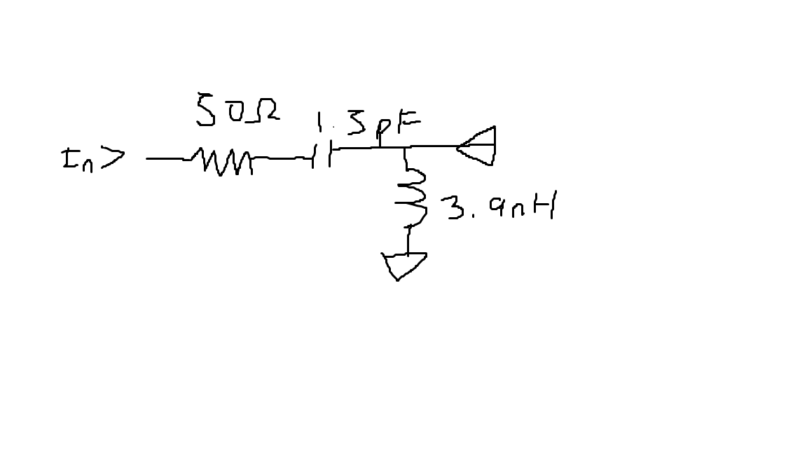

1. Our Delta frequency +3dB is 2.7-2.2 = 0.5 GHz. The center is at 2.44 GHz, so Q = 2.44 GHz/0.5 GHz. $Q=(2.44e9)/.5e9$ = 4.88.
2. Using our equations, Xc = 102.6Ohm, Xl = 29.38, this Znet = ~ 41.18Ohm. (I think that is the impedance of the antenna).

5

1. Length Average (wavelengths) = (length average)/v/f.
2. 2400-2500 avg = 2450MHz. Average length = 50+46.46+66/3 = 54.153 mm. Wavelength = v/f, V = 3e8, F = 2.45GHz, Lambda average = 122.36mm, thus making the antenna 0.4426 wavelengths long, on average.

6

1. The spikes are not made of metal, because conductive material would create a capacitive and inductive effect, losing power.
2. With less return loss, greater magnitudes mean more signal is getting to the output. In fig 3.1 we see that the return loss with smaller magnitude corresponds to the lower signal efficiency, while higher return loss magnitude corresponds to higher efficiency.